Narrative: Enhancement One: Software Design/Engineering
SNHU CS 499
Kevin Bristow
- Briefly describe the artifact. What is it? When was it created?
For my artifact, I opted to create my own website to showcase my skills instead of enhancing previous projects. The website I am creating is a full-stack application that acts as a digital library/note taking app where users have personal accounts and can add notes for individual books in their library. This tech-stack consists of MongoDB, Express, and NodeJS. Below is the high-level design for this project.
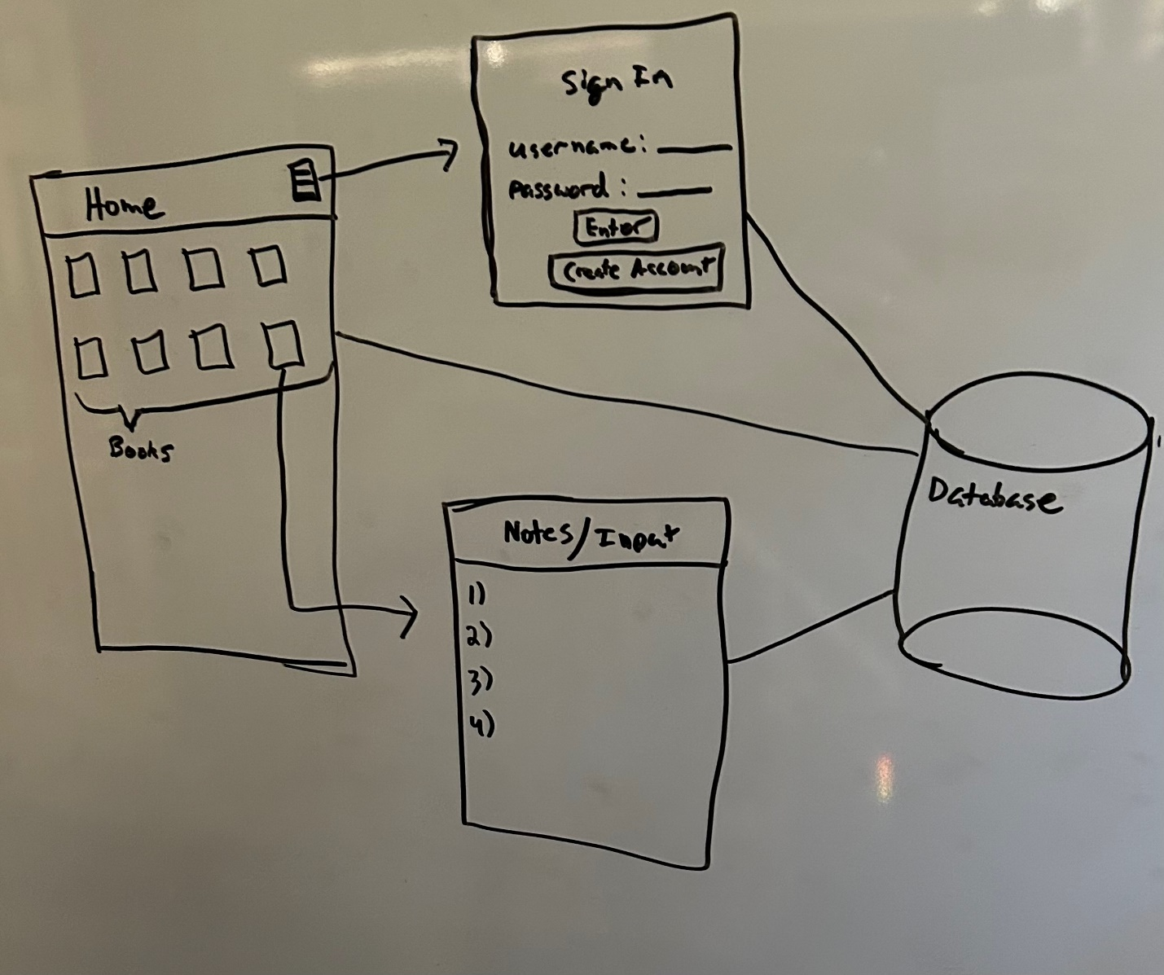

- Justify the inclusion of the artifact in your ePortfolio. Why did you select this item? What specific components of the artifact showcase your skills and abilities in software development? How was the artifact improved?
I chose to make a full-stack application from scratch because I feel that it will demonstrate my skills to an employer and it covers all five of the course outcomes. In regard to software design/engineering, this artifact touches on my ability to employ strategies for building a collaborative environment by connecting my project to the Git platform, allowing for others to collaborate if they wish; Design, develop, and deliver oral, written, and visual communications through my project documentation; and demonstrating my ability to use well-founded techniques and skills through my project design and implementation.
- Did you meet the course outcomes you planned to meet with this enhancement in Module One? Do you have any updates to your outcome-coverage plans?
The creation/enhancement of this artifact meets the three course outcomes that I described above. In the coming weeks the project will be built out to have full functionality and covering the requirements of incorporating data structures and algorithms and databases. The remaining course outcomes such as evaluating computing solutions and developing security features will be covered in the weeks to come.
- Reflect on the process of enhancing and modifying the artifact. What did you learn as you were creating it and improving it? What challenges did you face?
The design for this full-stack application is relatively simple because it is limited to a login screen, home screen, and notes screen, all connected to a database. Using the MEAN stack makes the codebase more cohesive because the only coding language one has to know is Javascript. The challenges that I am facing stem from the implementation of the design components into a working product. My two main challenges are building security into the app which requires implementing encryption of sensitive data and my other challenge is giving the user the ability to upload images for their books. Each challenge requires more thought/time than we previously thought which is a lesson I am learning throughout this process.

